- Workflow question - How do we determine the metadata if it's not filled in? (Do we just leave the field blank or does one of us fill it in? Can we document the workflows for this intake process?

A: The asset steward would work with the asset creator or owner to verify that any empty fields are intentionally left blank and not the result of missing information. Most of the fields are not required by design because applicability varies across assets of same class.
JON: ok. We’ll go with asset steward process then and assign stewards.

- Workflow question - How do we know who uploaded this entry? Is it listed in one of the fields?
We can get that from the database backend.
Note: we should be able to see who created the record in the changelog section. I’ll communicate with the team to see if this is a bug or a feature that’s not implemented.

JON: Any reason why we don’t expose who uploaded that in one of the summary fields?

- Audits - when are we planning on adding them as an inventory type again?
My roadmap is:
- Notifications for business obligations, followed by
- Audits
Rationale: depth over breadth
- What does the "explore" button do again? the relationships seem to load without pressing it.
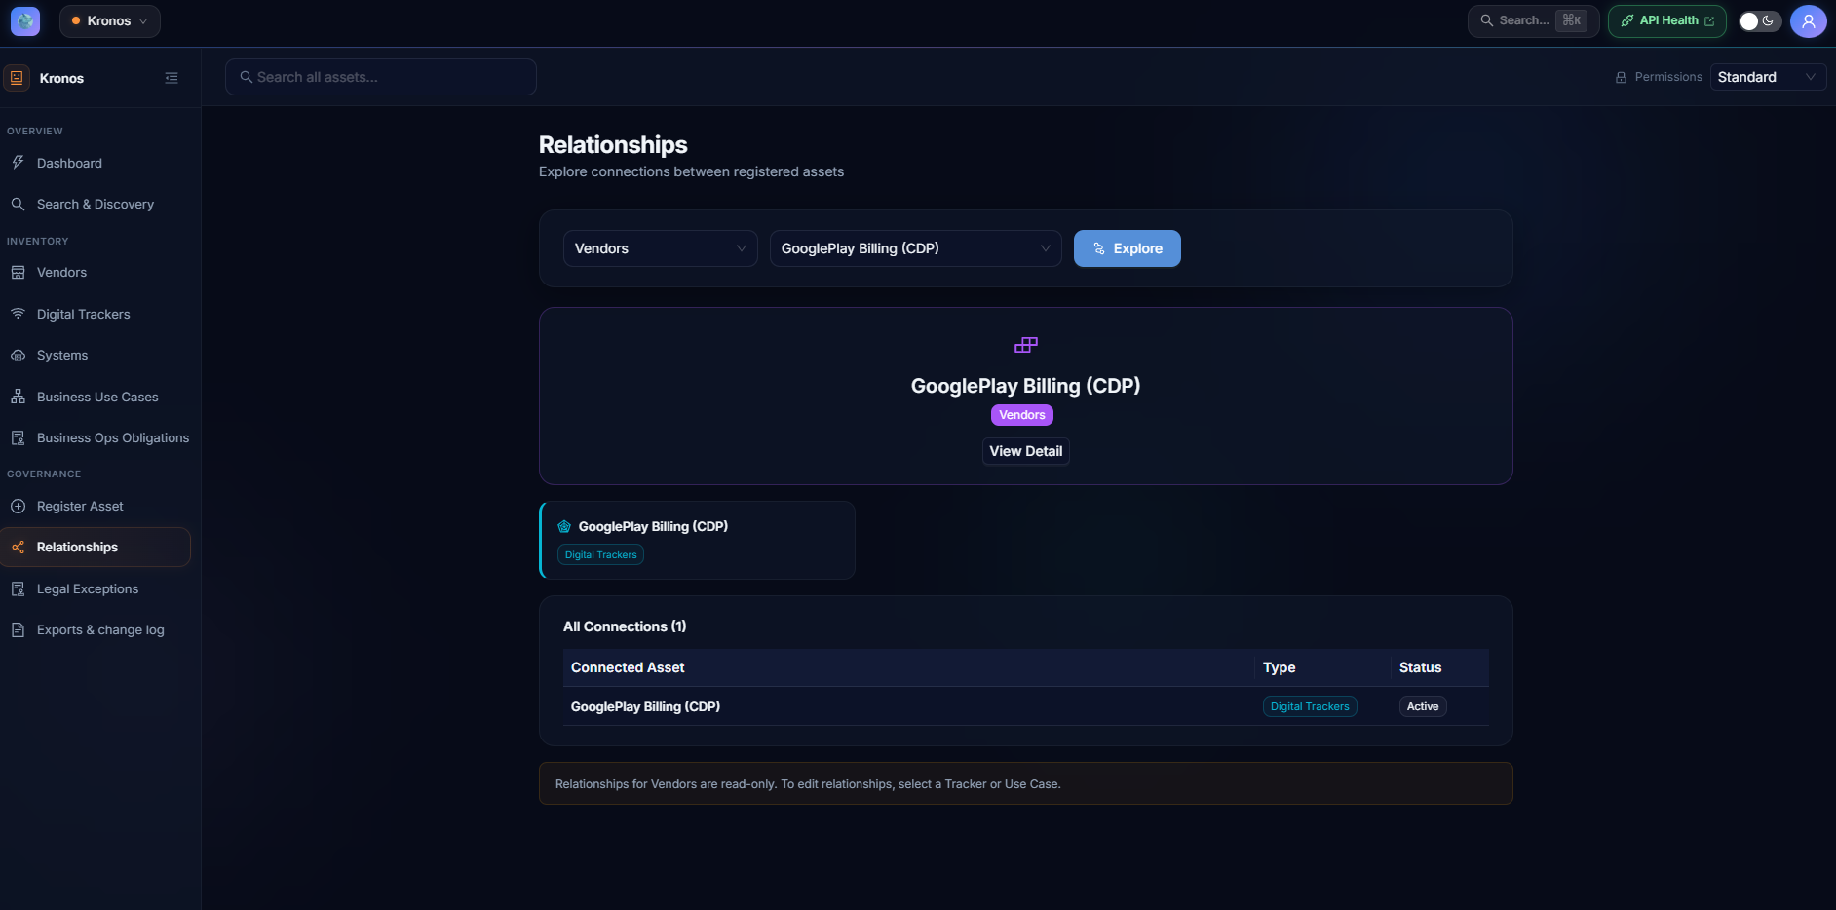
After “explore” is clicked, Kronos loads all the relationships found associated with the asset. The hero banner is the asset itself. Maybe not the best UI layout. I would suggest hiding “Relationships” because the same result can be achieved by search for the particular asset.

- 5) Do we have any legal exceptions yet? I forget, we were going to merge this with business use cases?
We don’t have any legal exceptions in the database; I can create one if needed.
Yes, we treat legal exceptions as a special case of business use cases.
Note: We made the decision to categorize legal exceptions as a special business use case. This might be a point of contention at some point. If needed we can make them separate. I just didn’t want to prematurely optimize something that we have very limited input/experience.
- I'm worried about scalability - I think we need to flesh out having stewards to own each of the inventory types.... Perhaps I can be the one for vendors, you can be the one for systems, perhaps Lakshm can be the one for trackers, Norman for business obligations.. etc. maybe we talk to Brenda. Thoughts here?
*What frequency do we want to keep auditing this, too?
I have every reason to believe that scalability would have been the “next” project that E&Y or any consultancy was going to push for after the database was built. That’s how McKinsey and the likes keep projects ongoing for years. What that means for us is:
Continual investment was going to be required.
Short-mid term: keeping the data fresh is going to require enforcement and manual input. Most likely this will be a top-down directive asking teams to be diligent with asset data input and have assigned stewards as enforcers (which is a thankless job, in a lot of cases this is where outside consultants are hired). Frequency: whenever a new asset is being used/acquired.
Long-term: we’ll need to build automation tools that gather these data, especially for trackers, systems, use cases, and their relationships. Building automated scanning tools also would have been E&Y’s next project to sell. There’s simply no way we would accept prolonged manual data input, AI era or not. Frequency: whenever a new asset is being used/acquired.
- Usability – Kronos is organizational intelligence platform for understanding business systems, vendors, trackers, and their relationships. Outside governance, this tool is used to
- Producer: Document the assets that we use. The nature of Krono’s data requires precision and consistency. AI, as of today, does not do a good job gathering Kronos data. For example, AI cannot definitively know what a tracker is doing on D+ streaming app on iOS. That’s why we need UI for data input. We have thin UI later for Kronos data consumer.
- Consumer: Intelligence providing side:
“What use cases require Adobe Heartbeat?” -> should return the same answer every time. “How much effort would it take to replace Adobe Heartbeat with XYZ?” -> Must accurately list out ALL the use cases associated with Adobe Heartbeat.

Summary: Different orgs have different decisions that Kronos can assist producing inputs. Outside DG and privacy, Kronos by and large is NOT a tool that someone would use every day. It is used when decisions are to be made. For example:
GIS: “Adobe tracker just got hacked, which of our products and data use cases are affected, are PII being compromised? Do we need to shut down any services?” – Operational visibility

Engineering: asset impact, asset duplications, “How many engineers would it take to replace tracker X? Should we?”
Real example: At Amazon, 0.01% of ad inventory on child profile were shown alcohol ads. -> Part of the triage process is identifying which system/tracker was responsible for propagating profile/age data. If those are working properly then move on to the next suspected issue.

Security and Privacy: What is Adobe Heartbeat collecting? Who is it sending data to?

Procurement: We need to track how VR headsets are being used with D+, can we use an existing tracker or do we need to onboard new trackers? Would replacing Adobe Heartbeat with X Heartbeat yield lower cost/performance?

